**A CRM APPLICATION FOR SCHOOLS/COLLEGES**

## INTRODUCTION

* 1. **Overview**

Project aim is to provide real-time knowledge for all the student who have basics knowledge of Salesforce and Looking for a real-time project. This project will also help to those professionals who are in cross-technology and wanted to switch to Salesforce with the help of this project they will gain knowledge and can include into their resume as well.

* 1. **Purpose**

A CRM application forms are designed to helps schools to manage the entire lifecycle of the student. With a CRM we can track and the data that’s important to our operations, all in one easy-to-access place. In this application, typically appear the form that required for registration of students, student profiles and data.

**2.2** **Problem Definition & Design Thinking**

2.1 Empathy Map

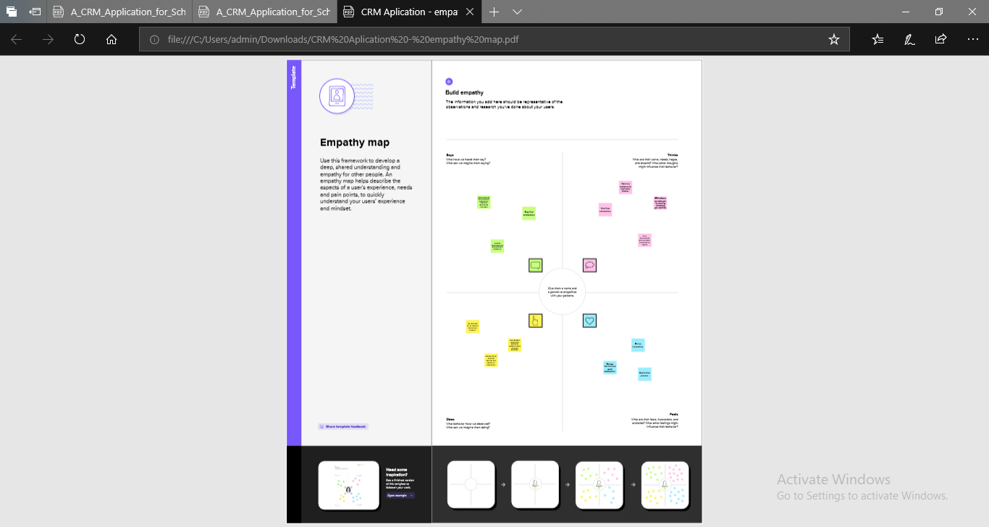

2.2 Ideation & Brainstorming Map

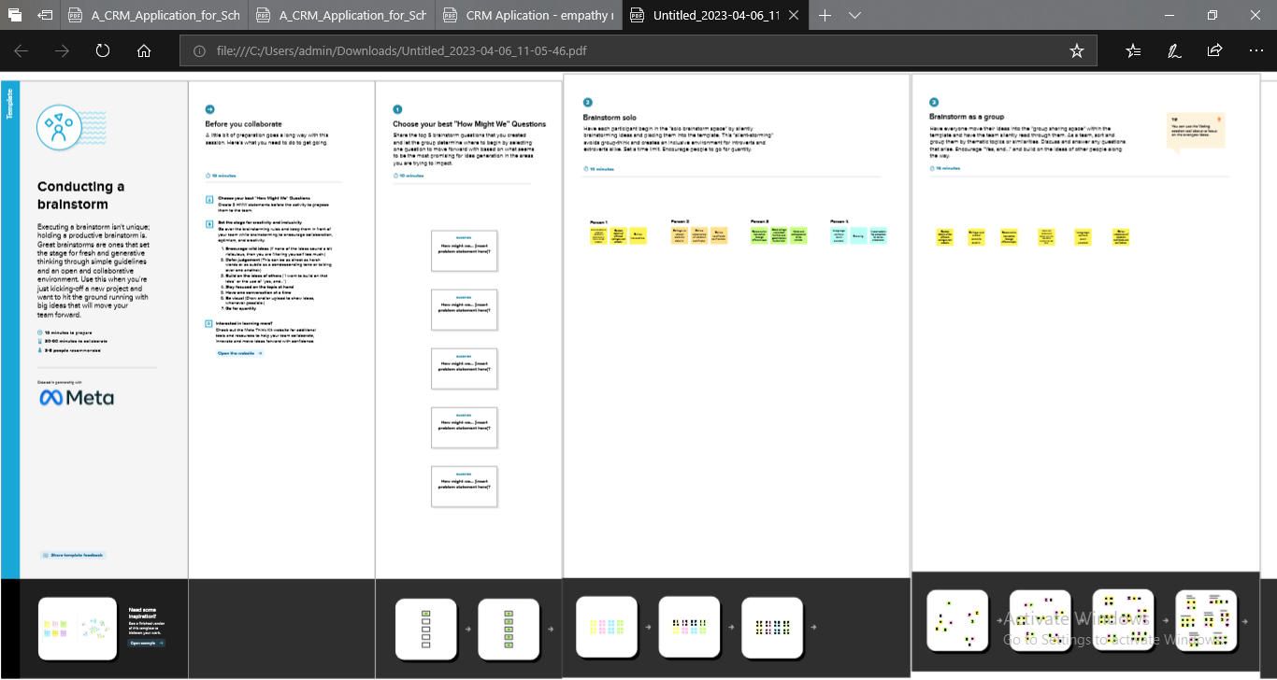

**3. RESULTS**

**3.1 Data Model:**

|  |  |  |
| --- | --- | --- |
| **OBJECT NAME** | **Fields in the Object** | |
| **Field Label** | **Data Type** |
| **SCHOOL SCHOOL** | Address | Text Area(225) |
| [Created By](https://governmentartsandscienc485-dev-ed.develop.lightning.force.com/lightning/setup/ObjectManager/01I2w000003XlOG/FieldsAndRelationships/CreatedBy/view) Created by | Lookup(User) |
| District | Text Area(225) |
| Highest Mark | Roll-up summary(MAX Student) |
| Last Modified by | Lookup(user) |
| Number of student | Roll-up Summary(COUNT) |
| Owner | Lookup( user, Group) |
| **N** Phone Number | Phone |
| School Name | Text(80) |
| School Website | Text Area(225) |
| State | Text Area(225) |
| **STUDENT** | Class | Number (18,0) |
| Marks | Number (18,0) |
| Phone Number | Phone |
| Result | Picklist |
| School | Master-Detail(school) |
| Student Student Name | Text(80) |
| **PARENT** | Created by | Lookup(user) |
| Last Modified by | Lookup(user) |
| **PARENT** | Owner | Lookup (Group, User) |
| Parent Address | Text Area(225) |
| Parent Name | Text(80) |
| Parent Number | Phone |

**Milestone 1**

**Activity: Creating a Developer Account**

1. Went to developers.salesforce.com/
2. Clicked on sign up.
3. On the sign up form, entered the following details :

a. First name & Last name

b. Email

c. Role : Developer

d. Company : College Name

e. County : India

f. Postal Code : pin code

g. Username : should be a combination of your name and company

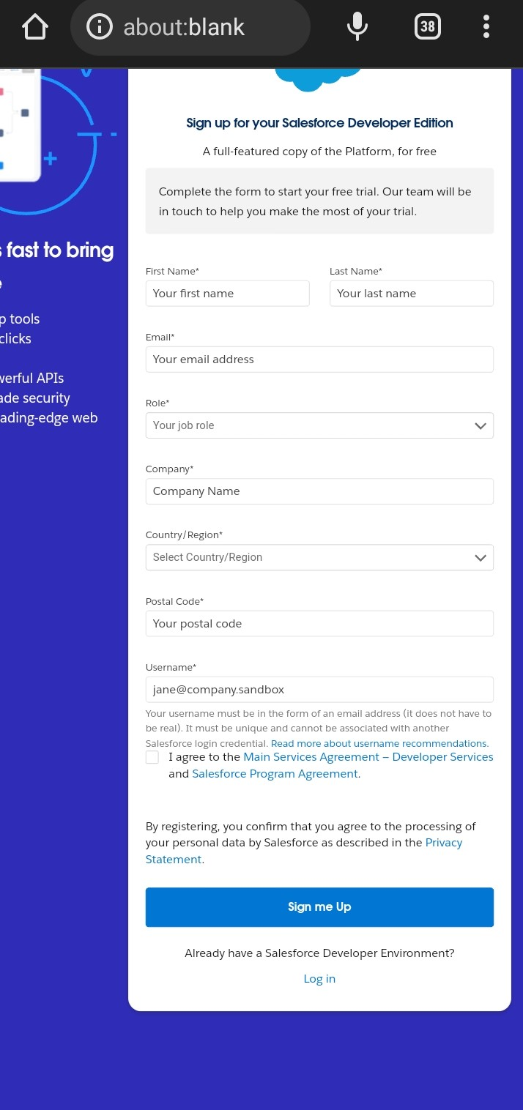

**Account activation**

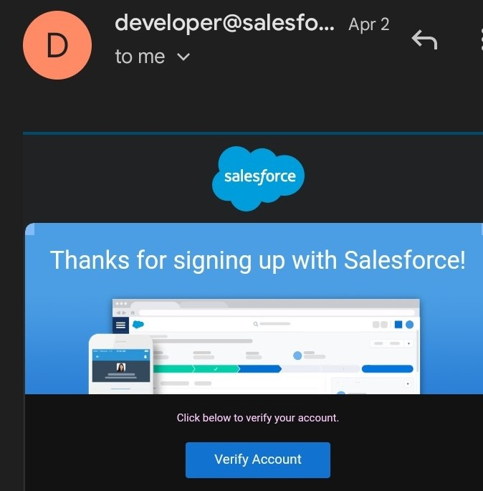

**LOGIN TO SALESFORCE**

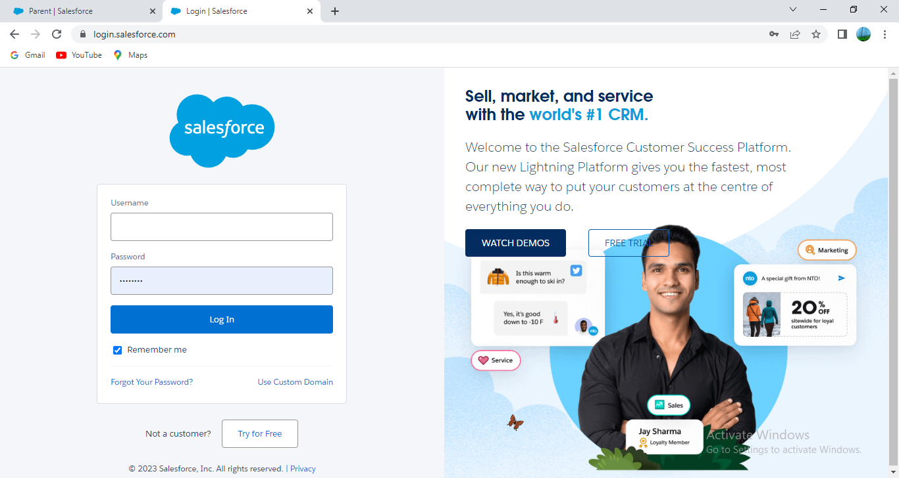

**Milestone 2 : Object**

Salesforce objects are database tables that permit us to store data that is specific to an organization. Salesforce objects are of two types : Standard Objects : Standard objects are the kind of objects that are provided by salesforce.com such as users, contracts, reports, dashboards, etc.

**Activity 1 : Creation of School Object**

For this school management we were created 3 objects i.e., school ,parents and students. Using the below steps.

1. Clicked on the gear icon and then selected Setup.
2. Clicked on the object manager tab just beside the home tab.
3. After the above steps, we had looked on the extreme right to us and found a Create Dropdown clicked on that and selected Custom Object.

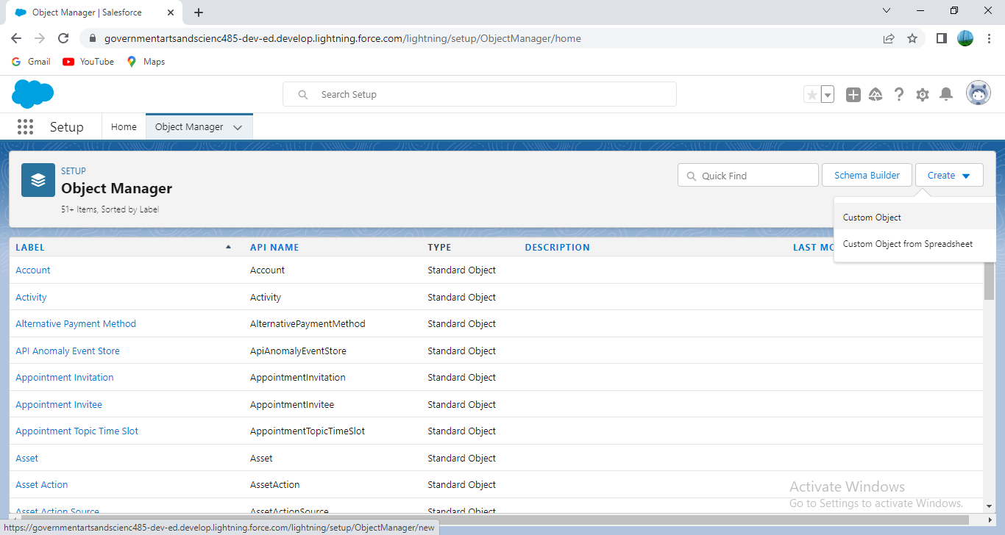

● On the Custom Object Definition page, created the object as follows:

● Label: School ; ● Plural Label: Schools ; ● Record Name: School Name;

● Checked the Allow Reports checkbox and Allow Search checkbox

● Clicked Save.

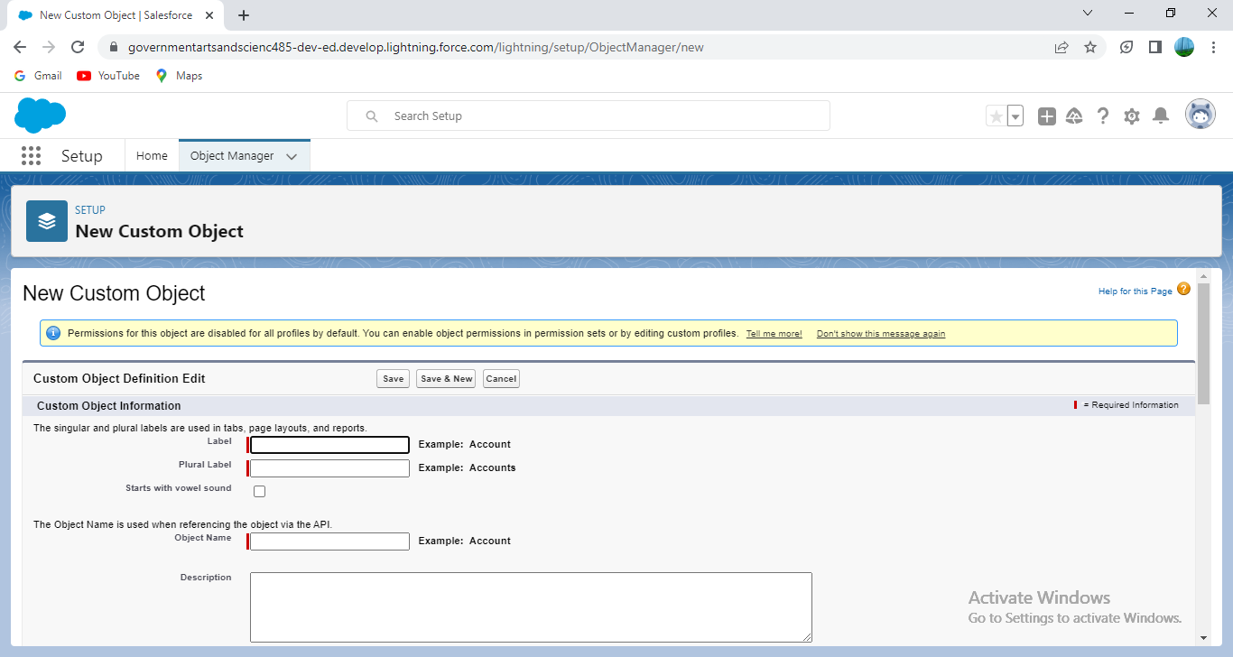

Then we created a custom tab. Clicked the Home tab, entered Tabs in Quick Find and selected Tabs. Under Custom Object Tabs, clicked New.

1.For Object, selected School. 2. For Tab Style, selected any one icon. 3. Leaved all defaults as is. Clicked Next, Next, and Save.

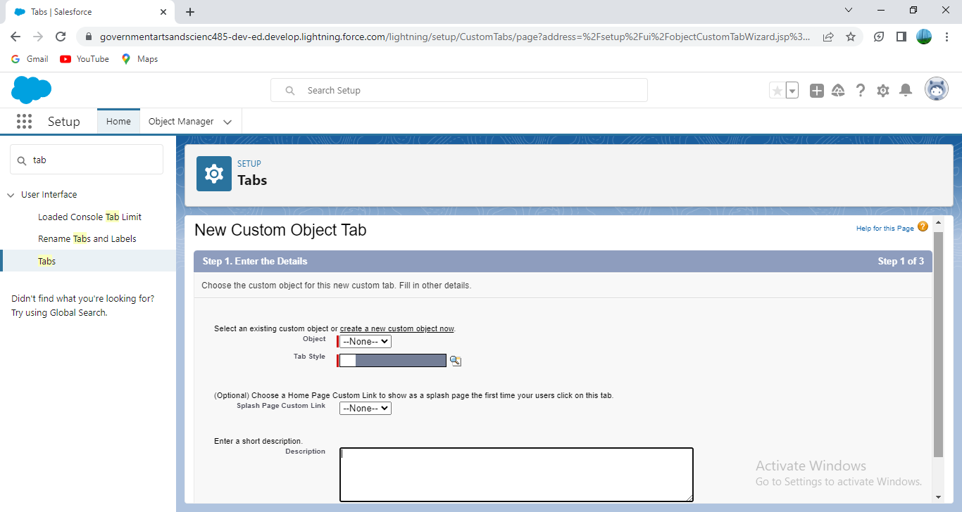

Similarly , we created for Students (**Activity1)** and Parents**(Activity2)**.

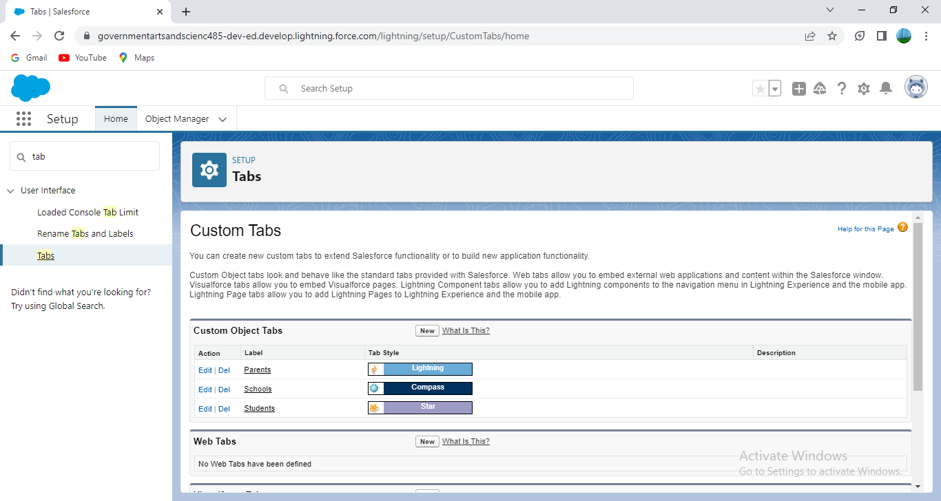

**Milestone 3 : Lightning App**

Apps in Salesforce are a group of tabs that help the application function by working together as a unit. It has a name, a logo, and a particular set of tabs. The simplest app usually has just two tabs.

**Activity:**

**Create the School Management app**

**●** From Setup, entered App Manager in the Quick Find and selected App Manager.

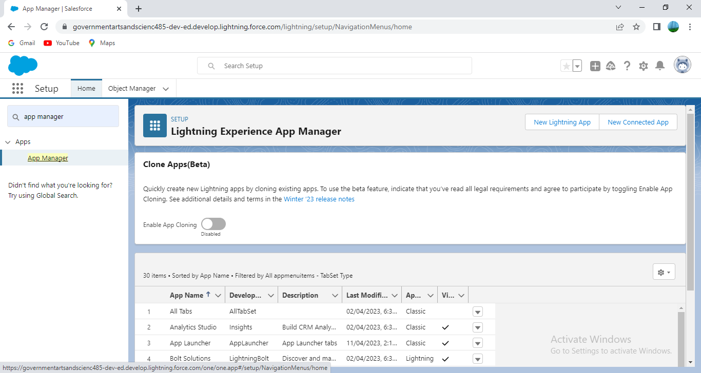

**●** Clicked New Lightning App. Entered School Managementas the App Name, then clicked Next

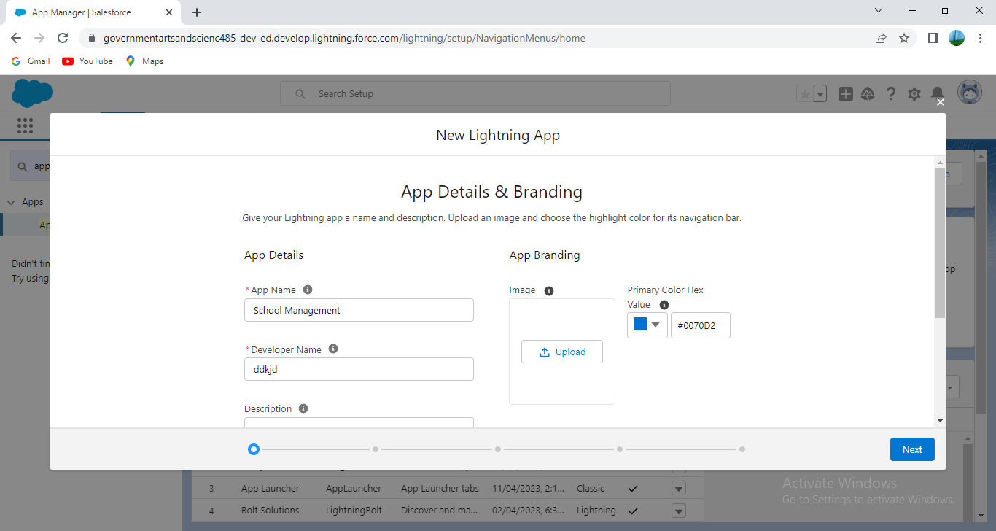

● Under App Options, leaved the default selections and clicked Next. ● Under Utility Items, leaved as is and clicked Next. ● From Available Items, selected Schools, Students, Parents, Reports, and Dashboards and moved them to Selected Items. Clicked Next.

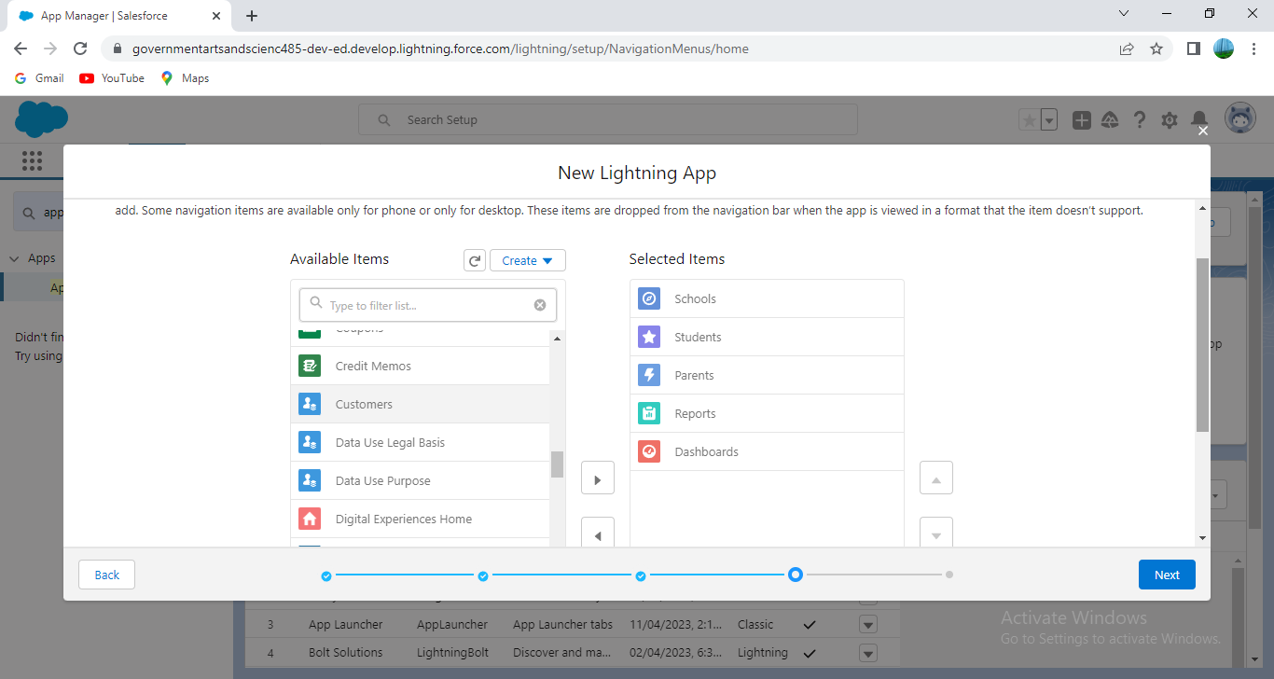

● From Available Profiles, selectedd System Administrator and move it to Selected Profiles. Clicked Save & Finish.

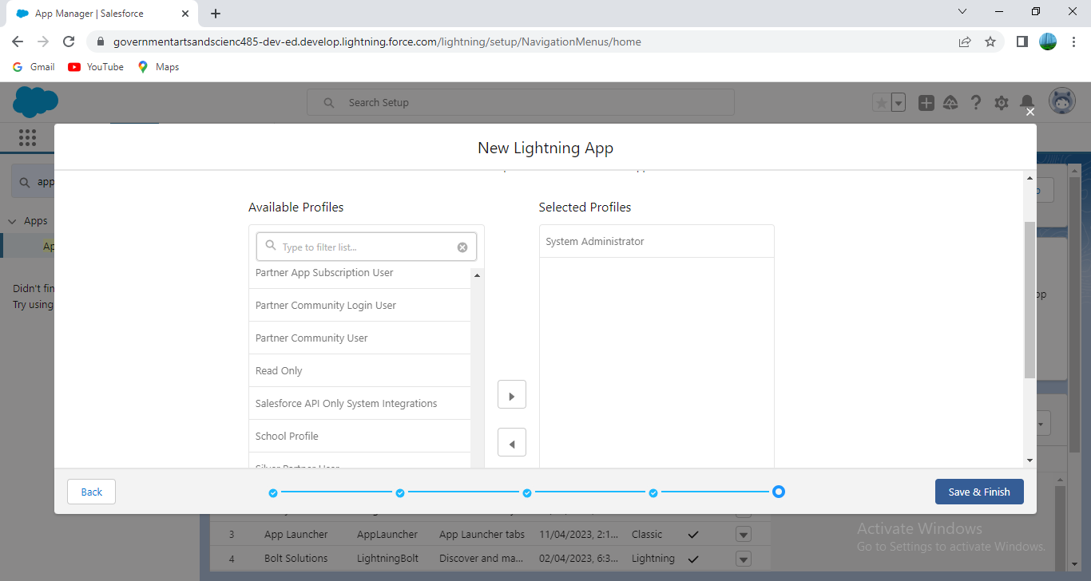

And verified my changes.

**Milestone -4 : Fields and Relationship**

An object relationship in Salesforce is a two-way association between two objects. Relationships are created by creating custom relationship fields on an object. This is done so that when users view records, they can also see and access related data.

Activity-1: Creation of fields for the School objects:

1. Clicked the gear icon and select Setup. This launched Setup in a new tab.
2. Clicked the Object Manager tab next to Home.
3. Selected School.
4. Selected Fields & Relationships from the left navigation, and clicked New.

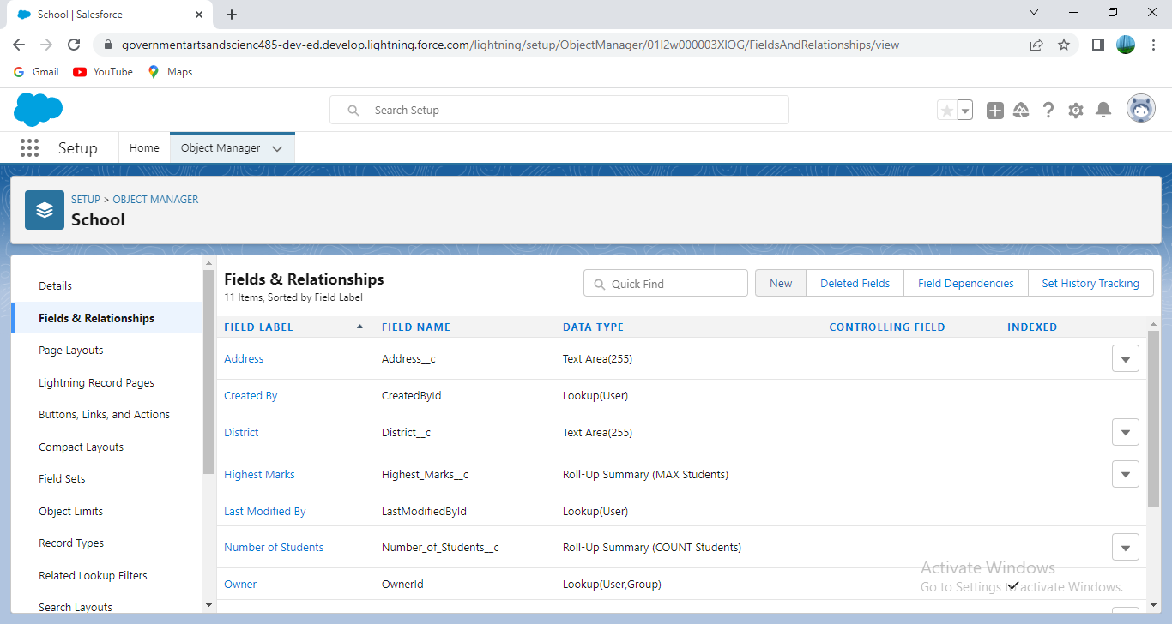

1.Selected the **Text Area** as the Data Type, then clicked Next. 2. For Field Label, entered Address. 3. Clicked Next, Next, then clicked Save & New.

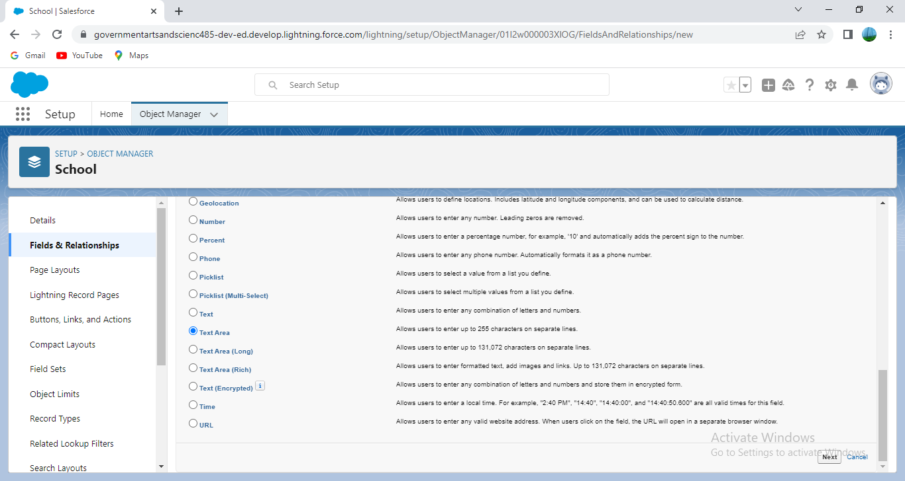

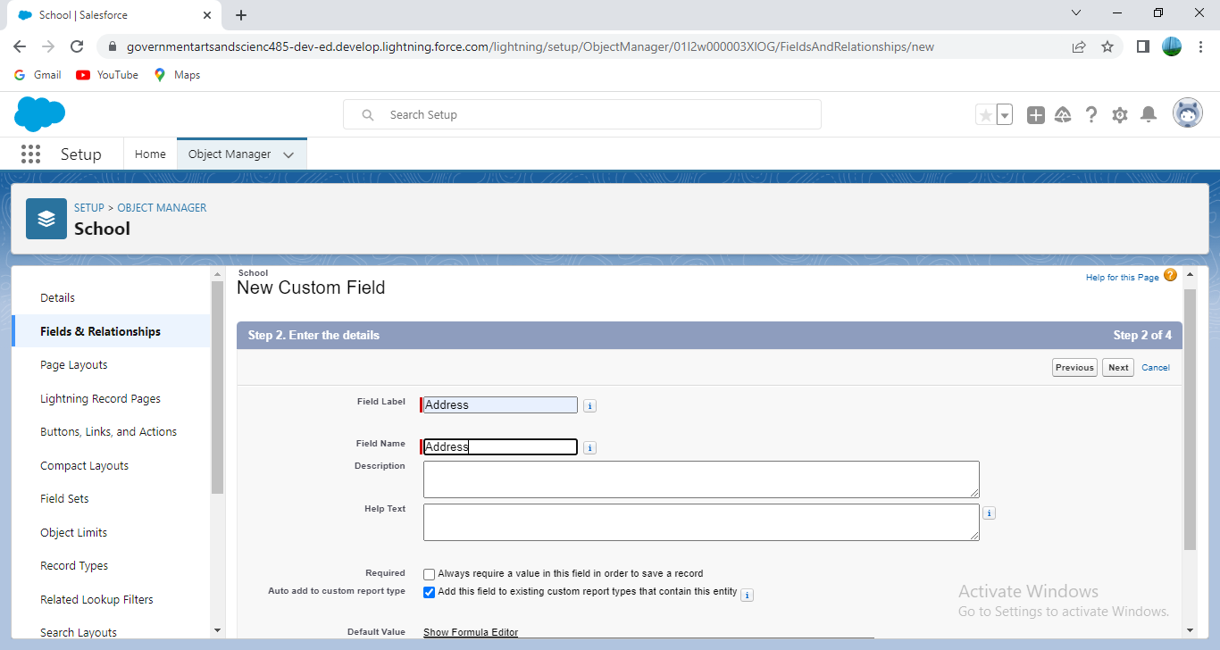

1. Followed steps 1 through 3 and created two more text areas with District, State and School websites as the field labels.

Then we created the other fields and chose the data types of the fields .

1. Selected the **Phone** as the Data Type, then clicked Next.

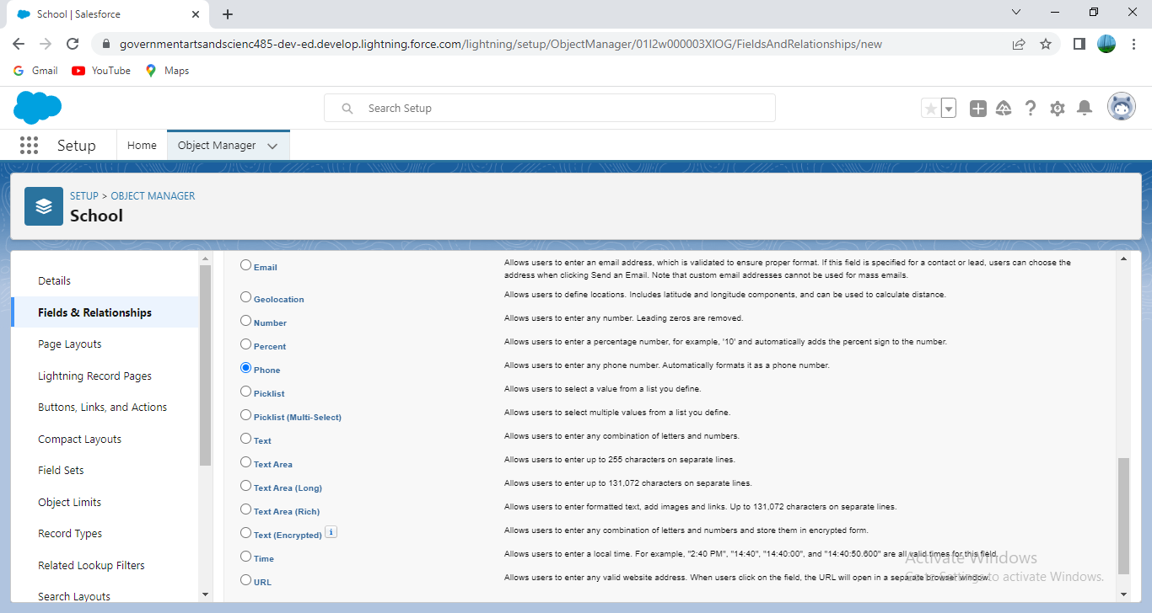

2. For Field Label, entered Phone Number.

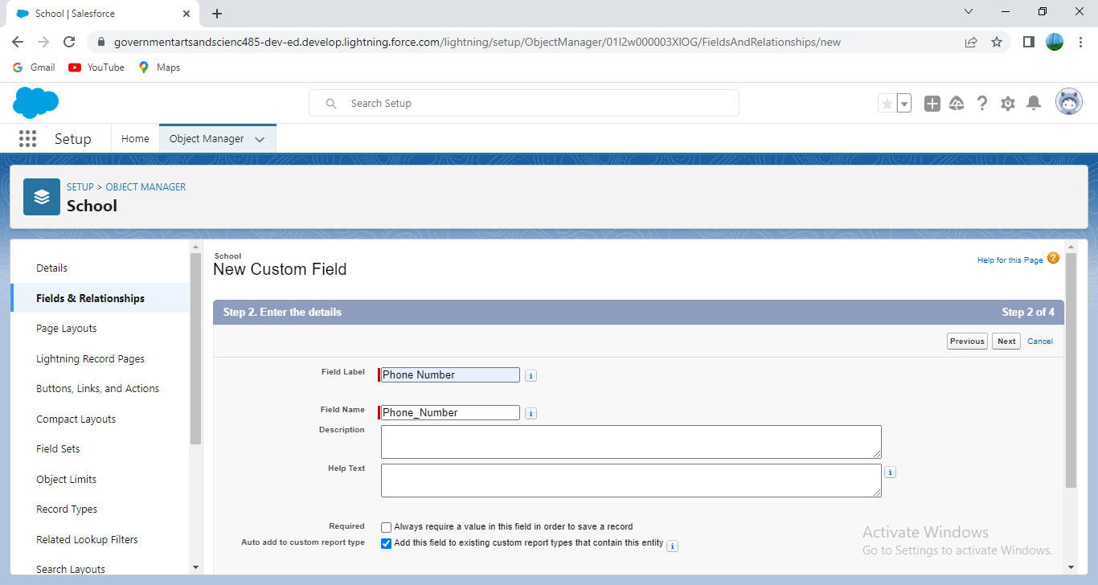

3. Clicked Next, Next, then clicked Save & New.

Then created **Roll-up summary** fields to calculate the number of students.

1. From Setup, clicked Object Manager and selected School. 2. Clicked Fields & Relationships, then New. 3. Selected the Roll-up summary field as data type

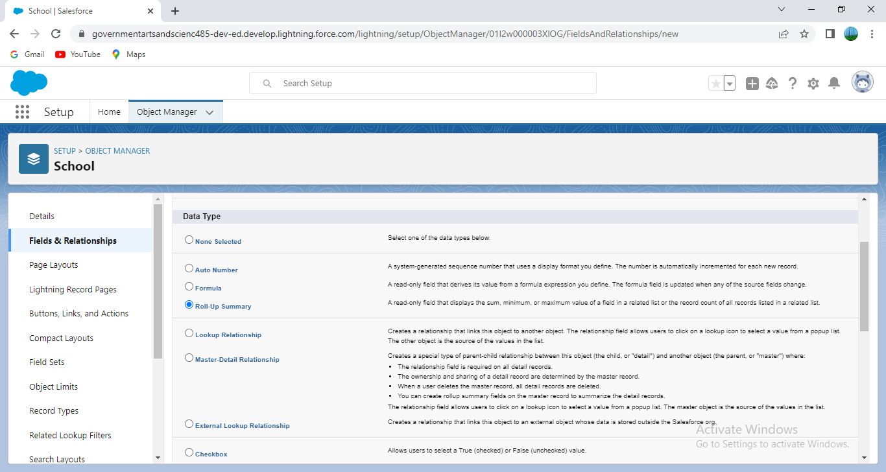 4. Entered the field label as Number of students

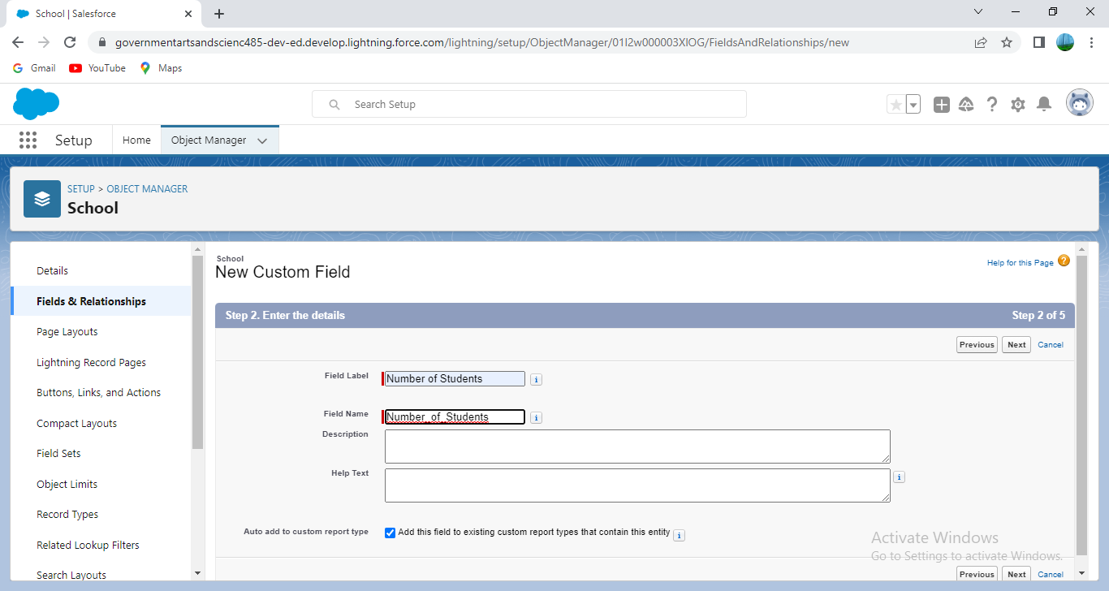

1. Clicked Next 6. Then selected the master object summarized as students and then selected count as roll-up and then clicked Next, Next and save.

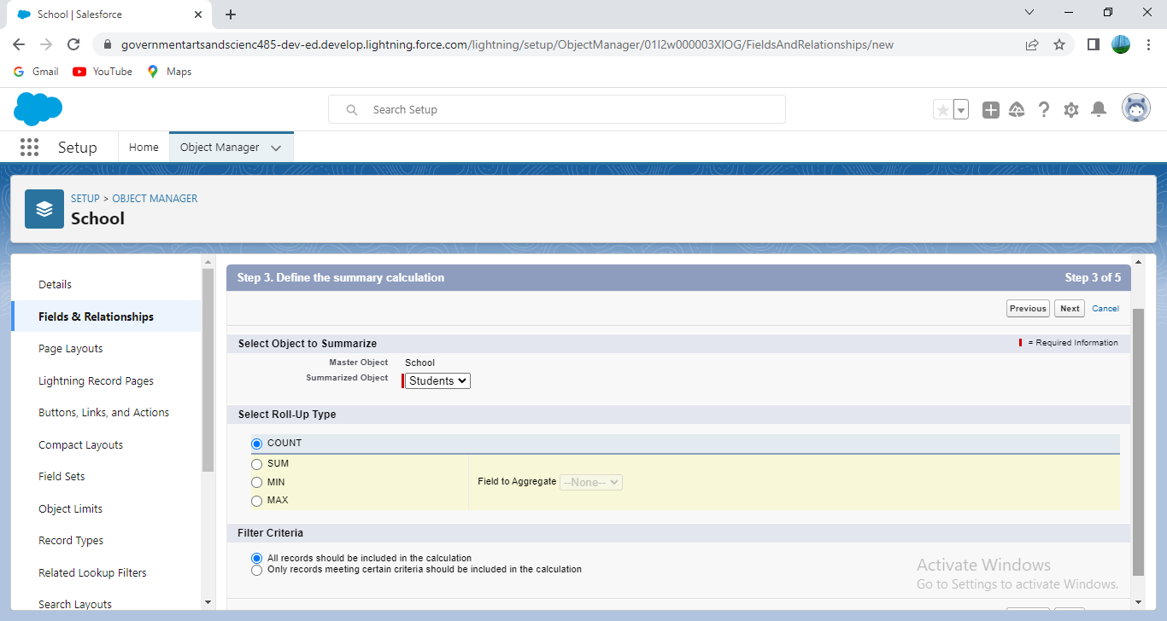

1. From Setup, clicked Object Manager and selected School. 2. Clicked Fields & Relationships, then New. 3. Selected the Roll-up summary field as data type

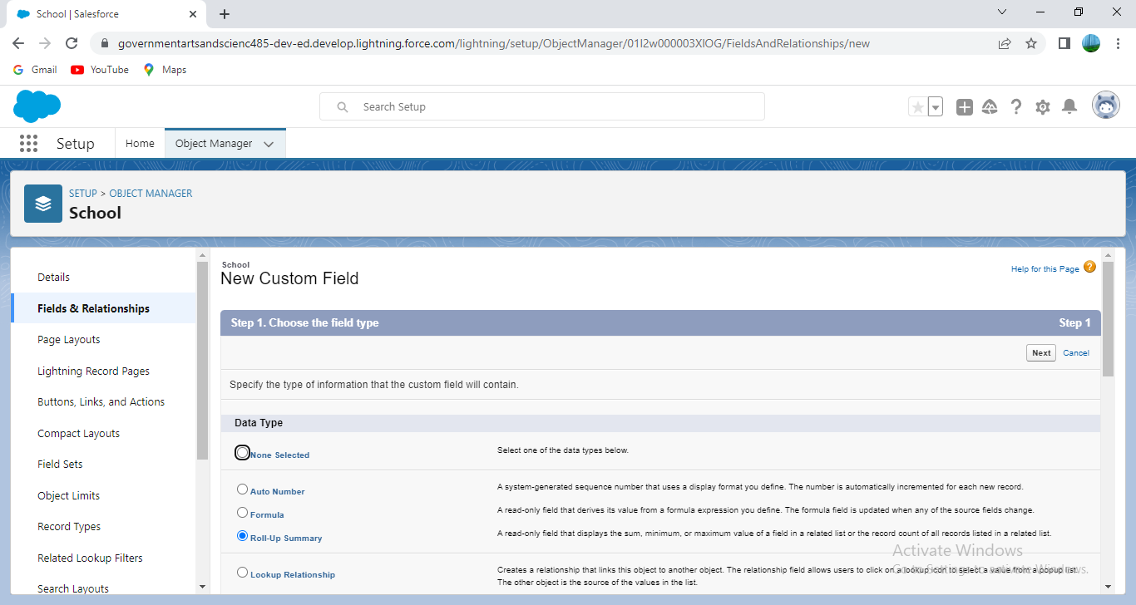

4. Entered the field label as Highest Marks

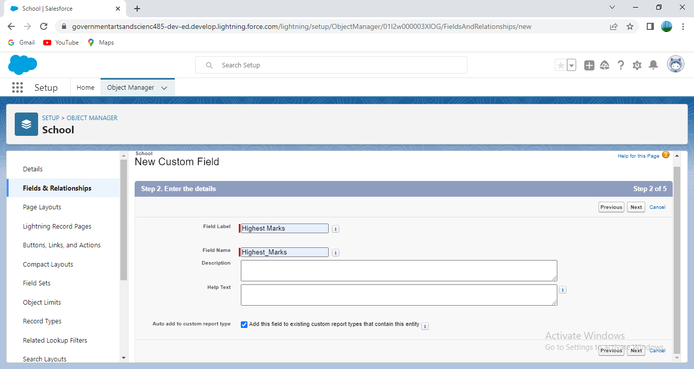

1. Click Next 6. Then selected the master object summarized as students and then selected Max as roll-up and then select Marks as field to aggregate. Clicked Next, Next and save.

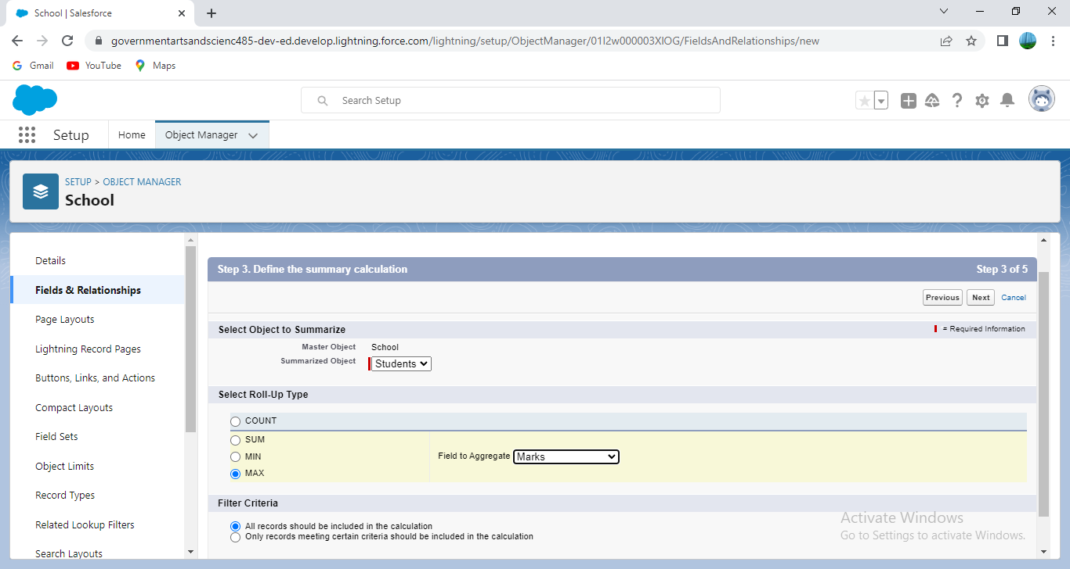

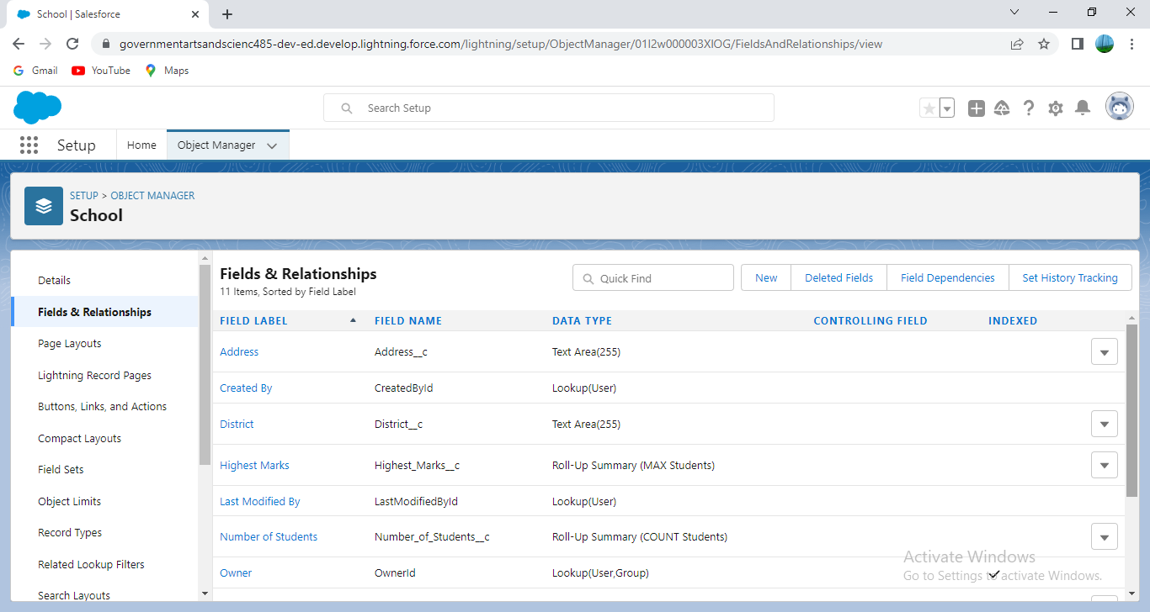

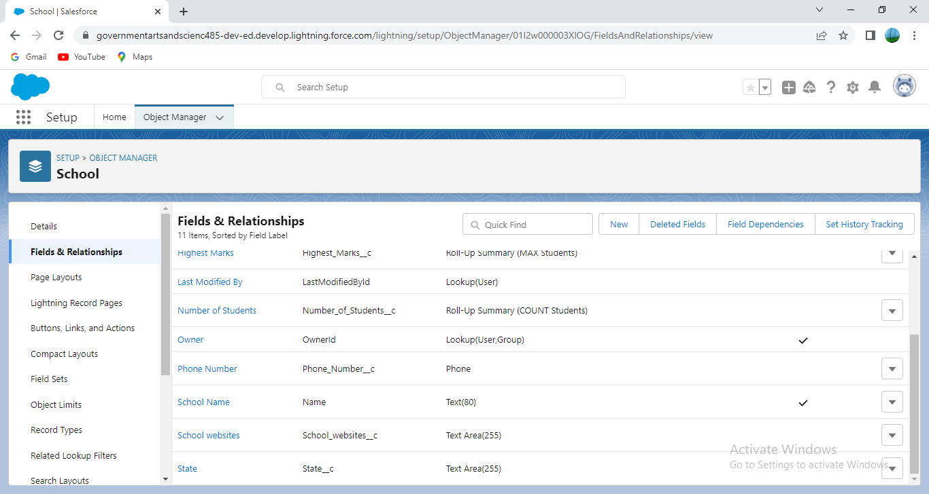

Activity-2: Creation of fields for the Student objects:

1.Selected the Phone as the Data Type, then clicked Next.

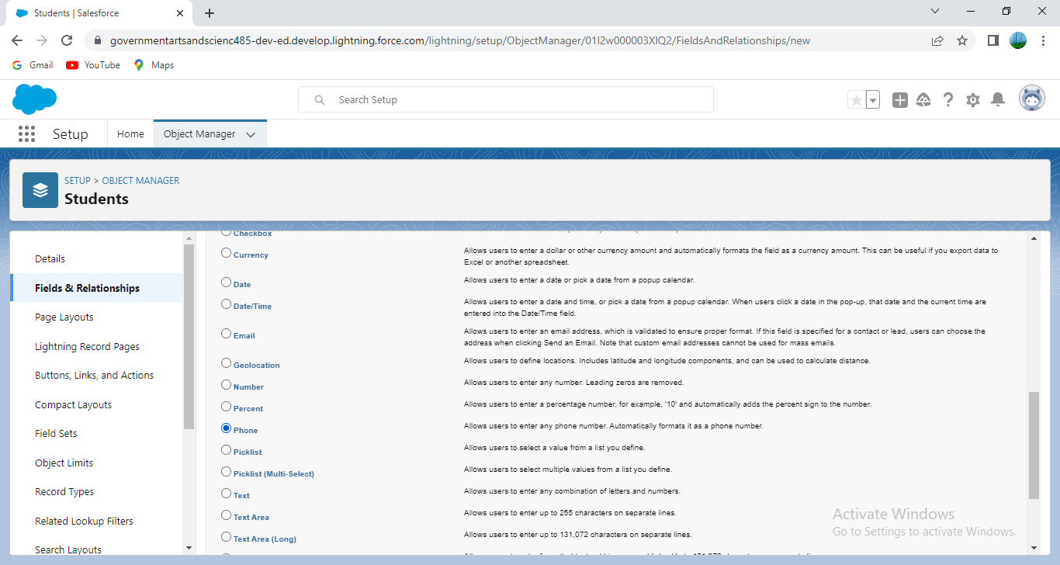 2. For Field Label, entered Phone Number.

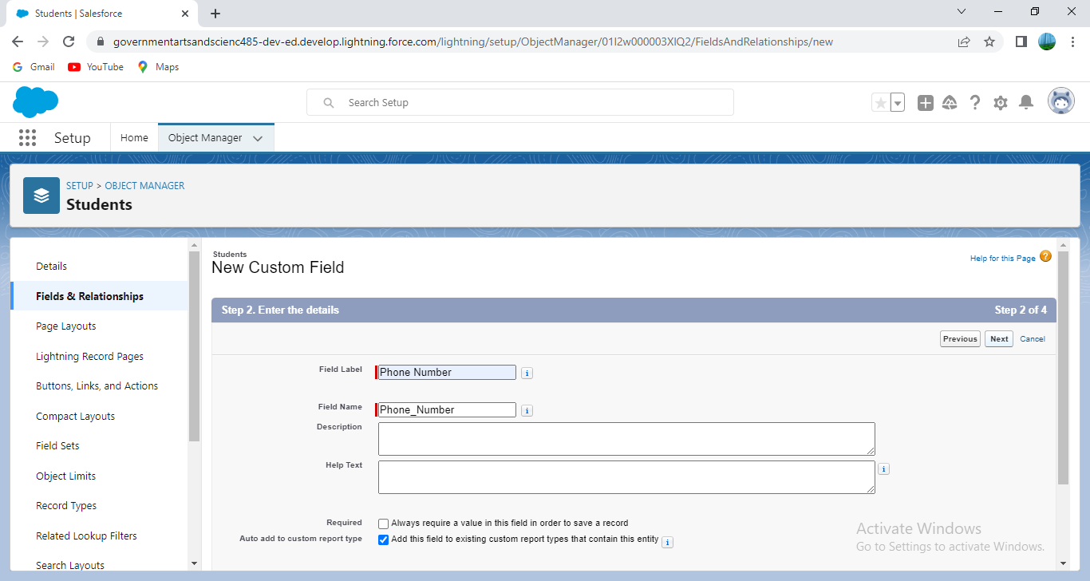

3. Clicked Next, Next, then Save & New.

Then create a master-detail relationship with school object

1. Selected Master-Detail Relationship as the Data Type and clicked Next.

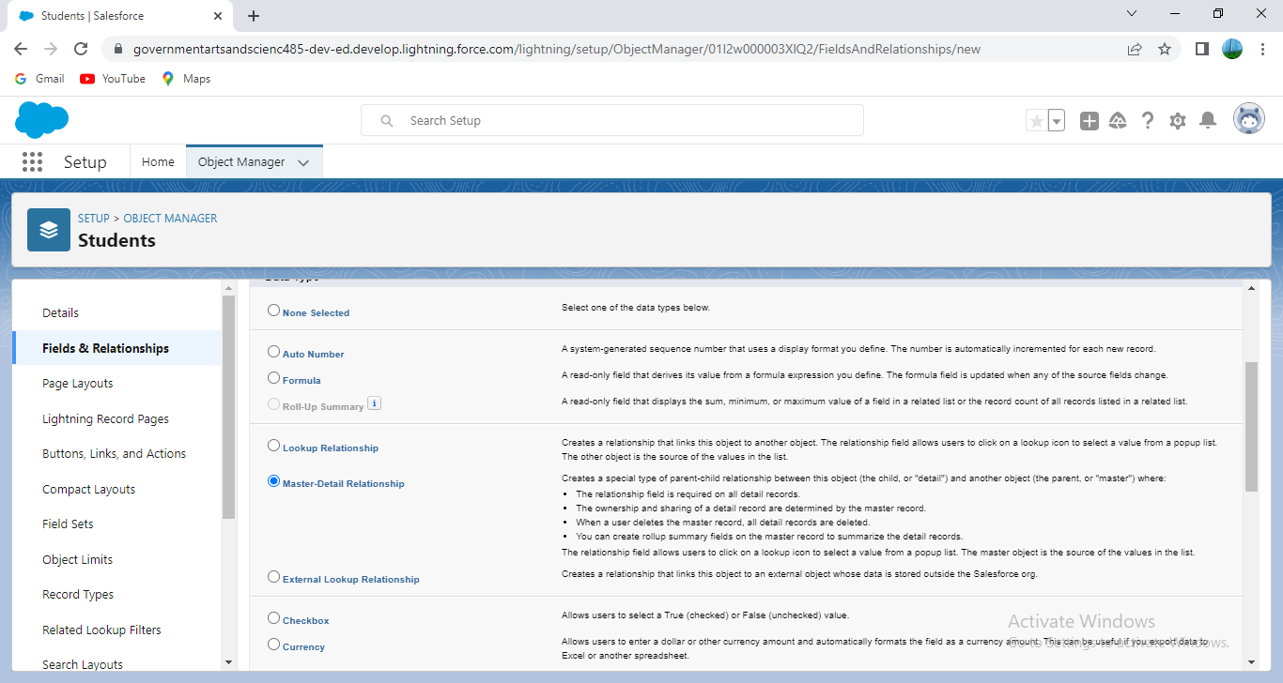

2. For Related to, entered School.

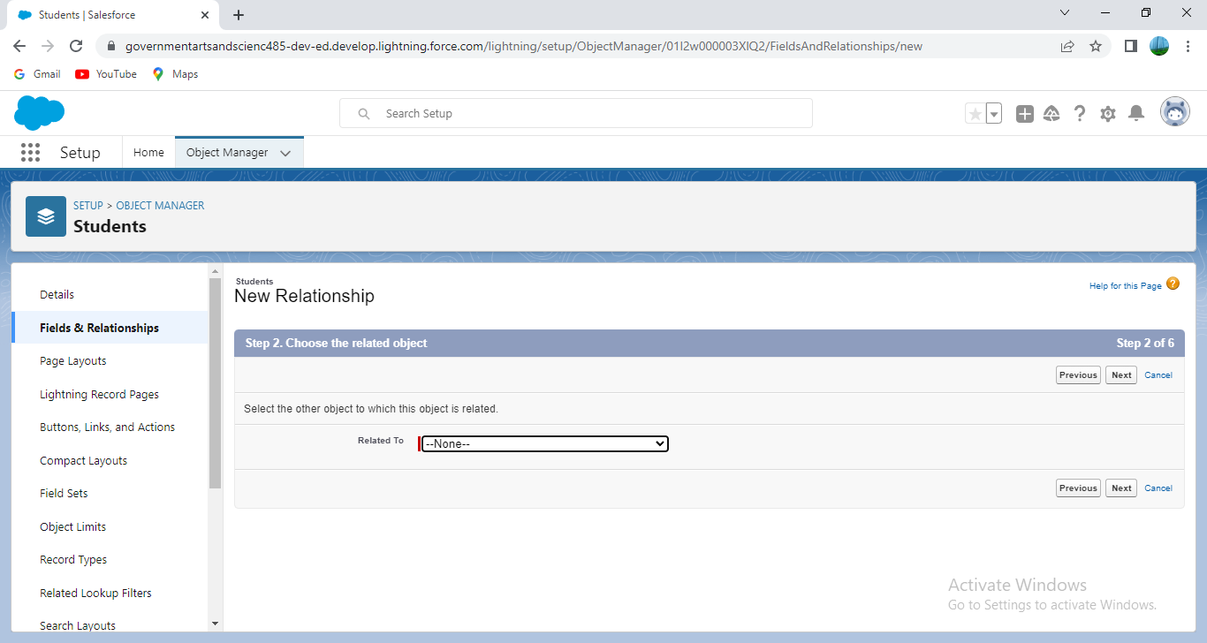

3. Clicked Next. 4. For Field Label, entered School.

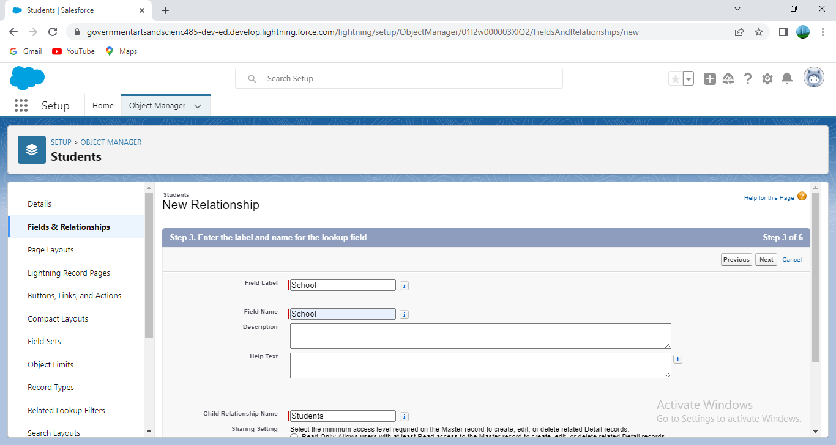

5. Clicked Next, Next, Next and Save.

Then create a Pick-List field:

1. From Setup, clicked Object Manager and selected Student. 2. Clicked Fields & Relationships, then New. 3. Selected Picklist as the Data Type and clicked Next.

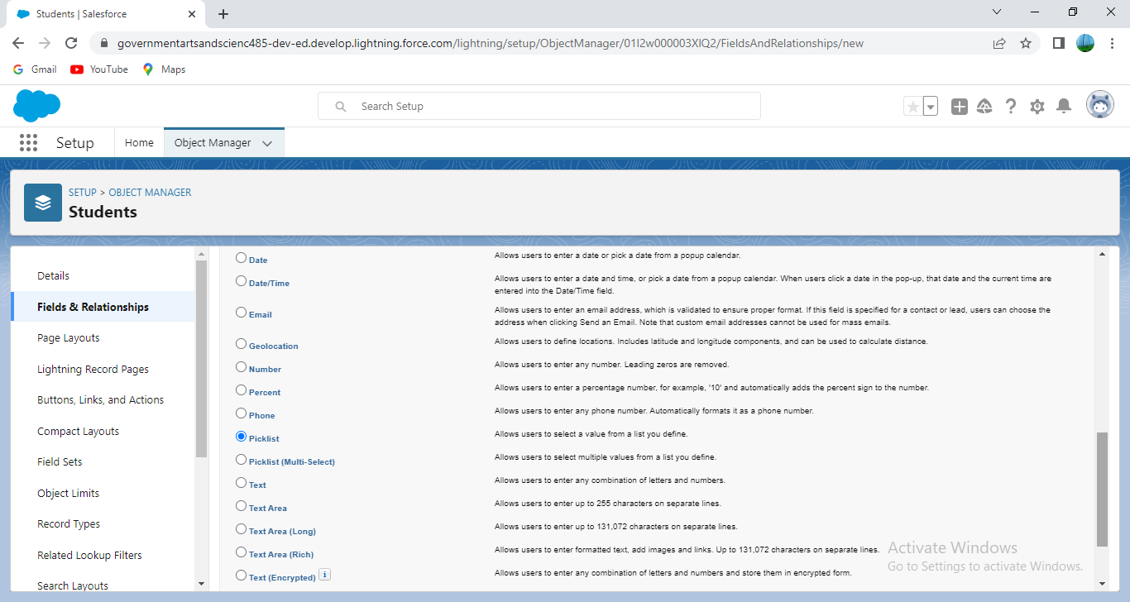

4.For Field Label entered Results. 5. Selected Enter values, with each value separated by a new line and entered these values: 6. Pass 7. Fail

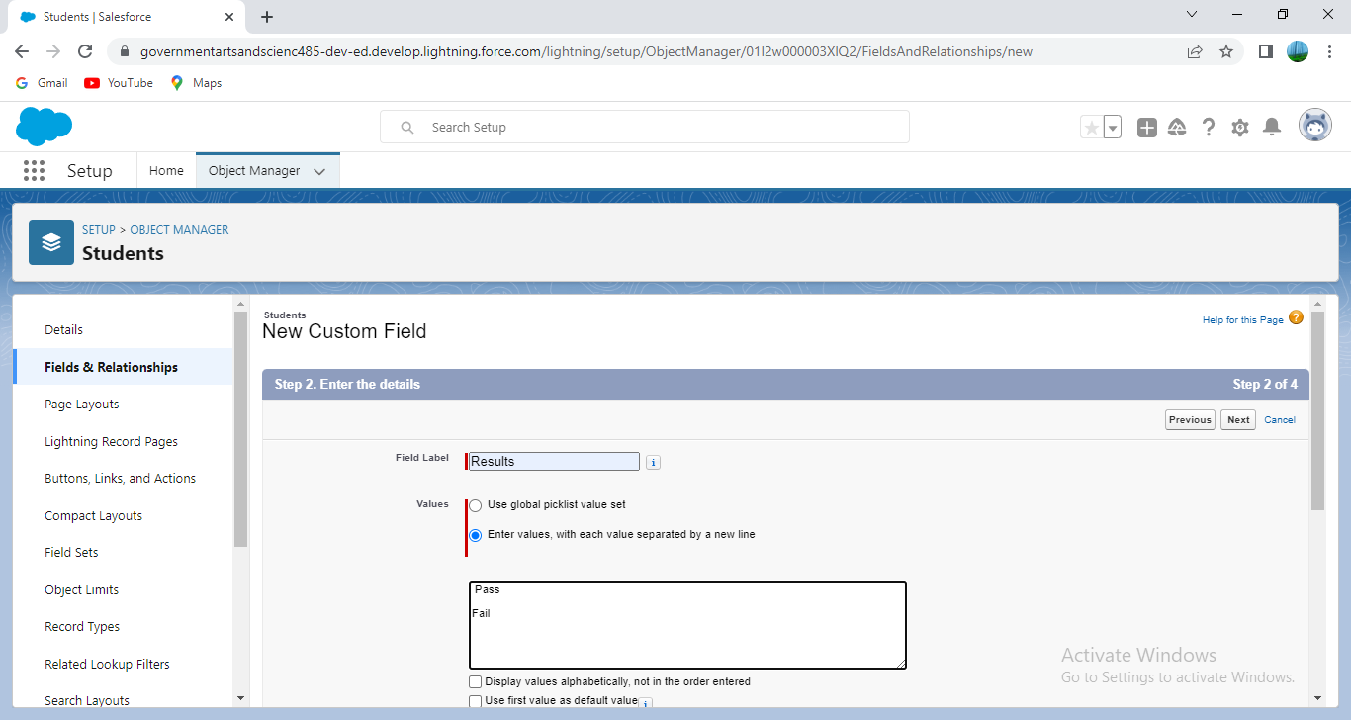 8. Clicked Next, Next, then Save & New

**Creating a Number field:** 1. Selected the Number as the Data Type, then clicked Next.

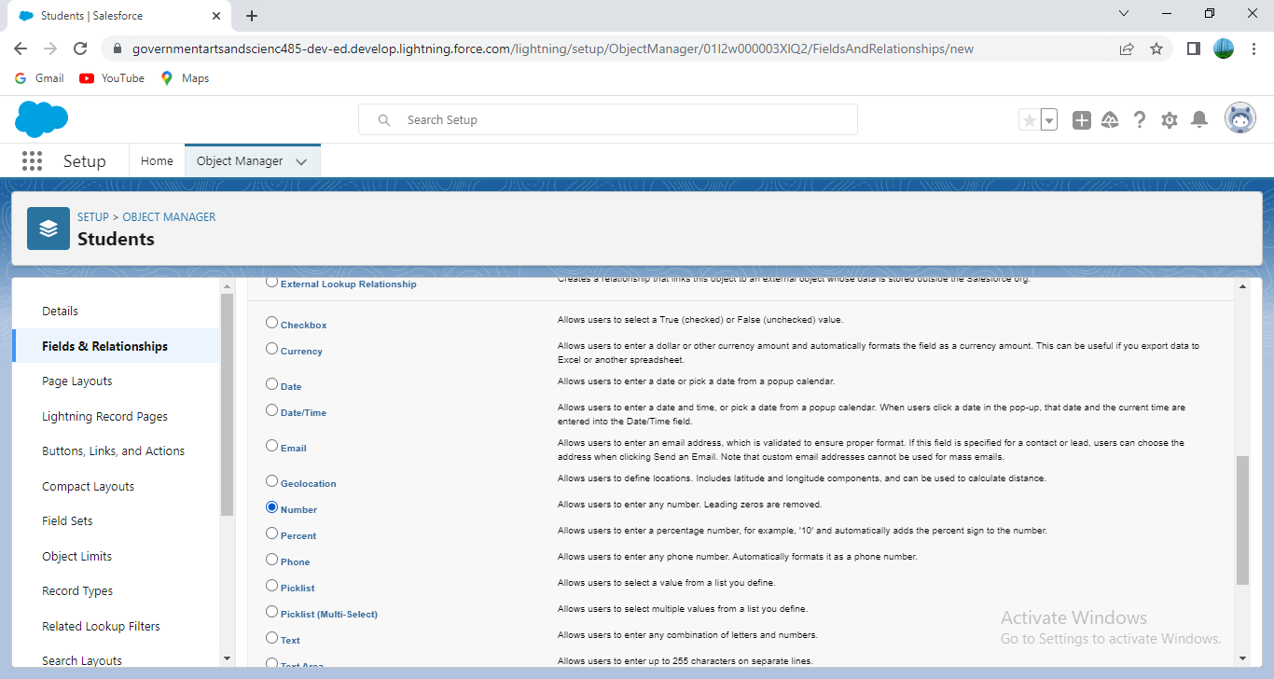

2. For Field Label, entered Class. 3. Clicked Next, Next, then Save & New

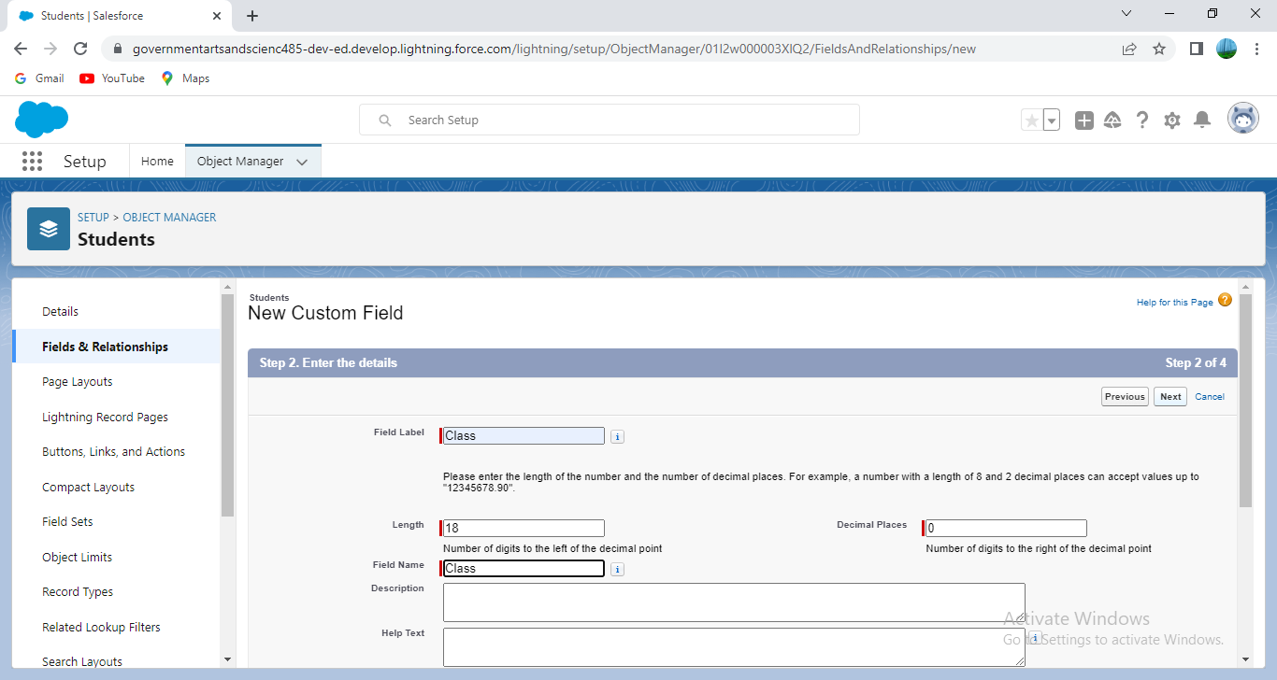

1. Followed steps 1 through 3 and created one more number field with Marks as the field labels.

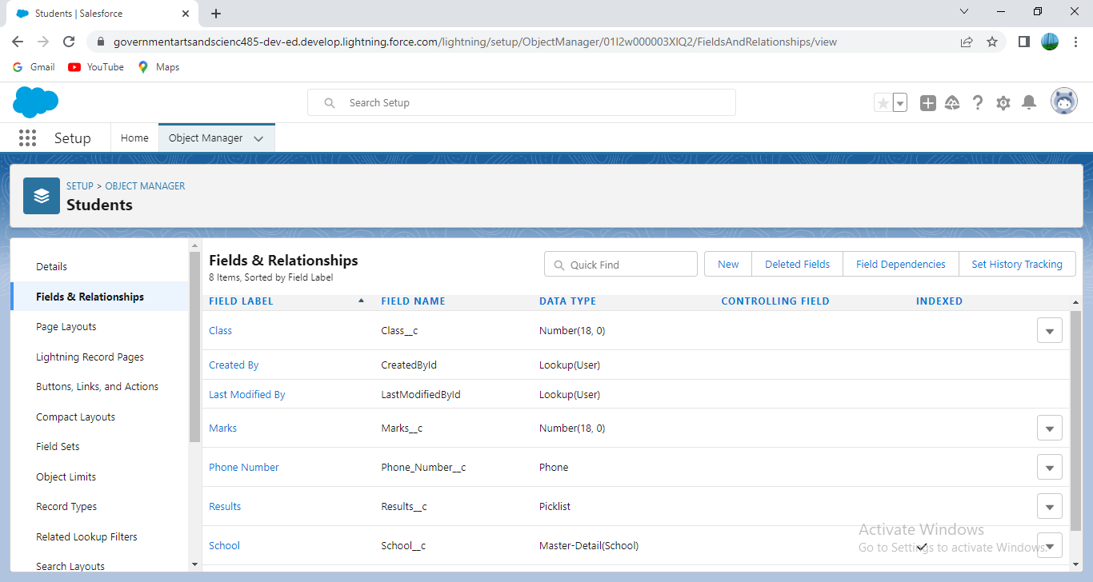

Activity-3: Creation of fields for the Parent objects:

1. Selected the Text Area as the Data Type, then clicked Next. 2. For Field Label, entered Parent Address. 3. Clicked Next, Next, then Save & New. 4. Selected the Phone as the Data Type, then clicked Next. 5. For Field Label, entered Parent Number. 6. Clicked Next, Next, then Save & New

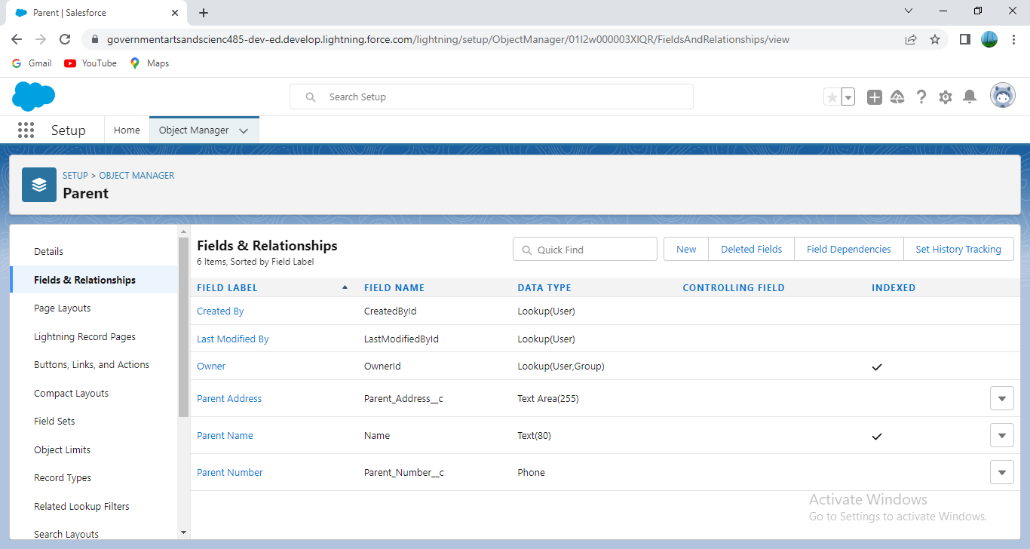

**Milestone-5: Profile**

A profile is a group/collection of settings and permissions that define what a user can do in sales force. A profile controls “Object permissions, Field permissions, User permissions, Tab settings, App settings, Apex class access, Visual force page access, Page layouts, Record Types, Login hours & Login IP ranges

**Activity:**

Creation on profile: From Setup entered Profiles in the Quick Find box, and then selected Profiles.

1. From the list of profiles Standard User was found. 2. Clicked Clone.

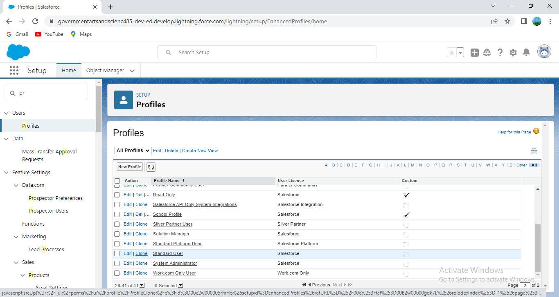

3. For Profile Name, entered School profile. 4. Clicked Save.

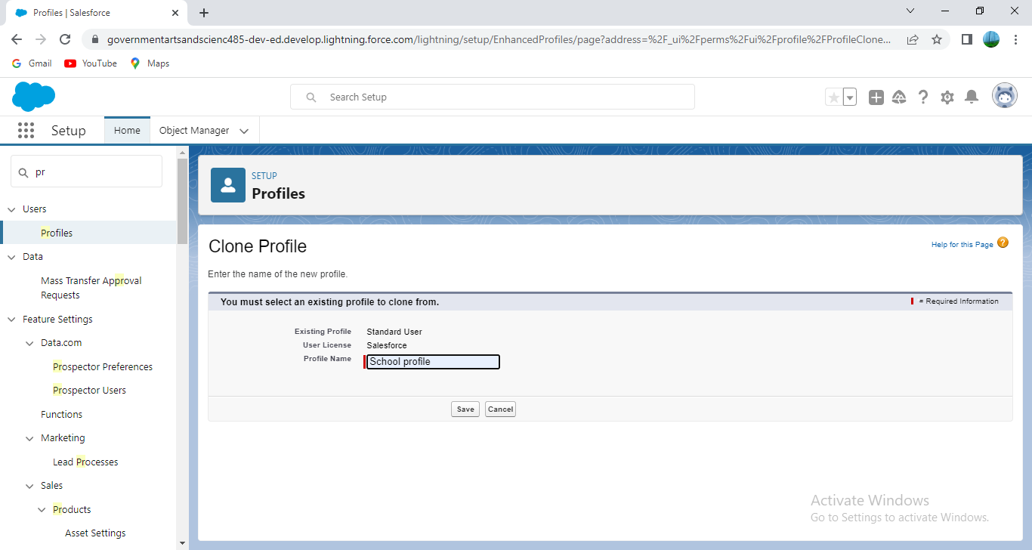

1. While still on the School profile page, then clicked Edit. 6. Scrolled down to Custom Object Permissions and Gave view all access permissions and assigned to the parent profile..

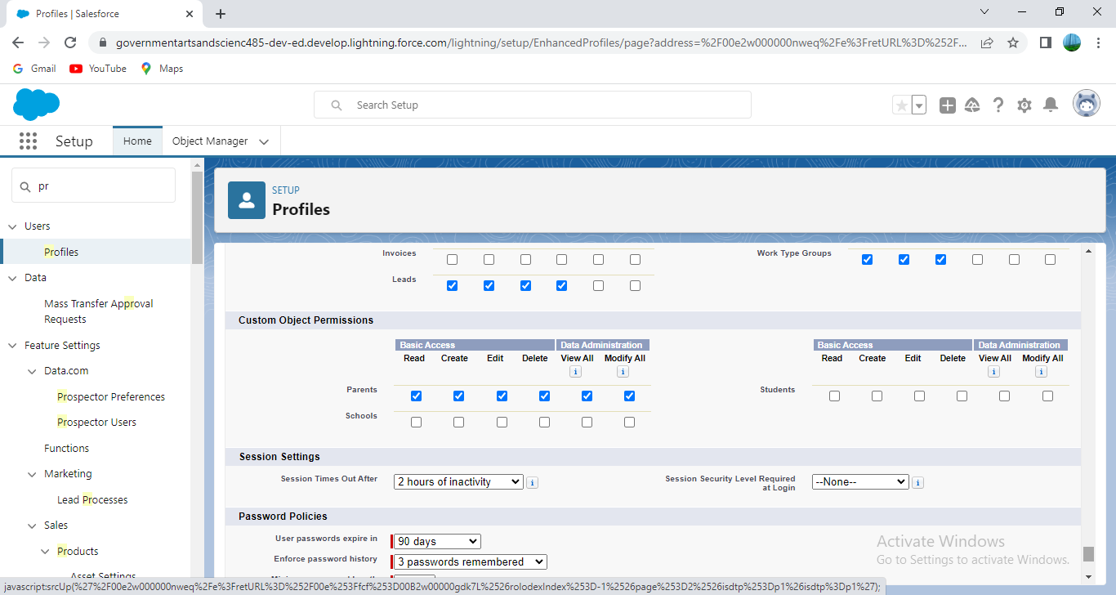

**Milestone-6: Users**

A user is anyone who logs in to Sales force. Users are employees at your company, such as sales reps, managers, and IT specialists, who need access to the company's records. Every user in Sales force has a user account.

Activity:

Creating a Users: 1. From Setup, in the Quick Find box, entered Users, and then selected Users. 2. Clicked New User.

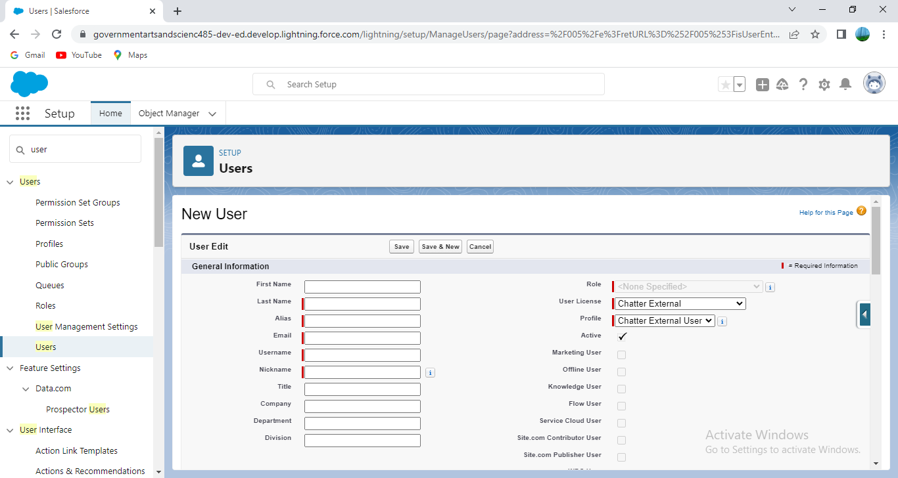

3.Entered the user’s name Parents and (our) email address and a unique username in the form of an email address. By default, the username is the same as the email address. 4. Selected a User License As sales force. 5. Selected a profile as a School profile. 6. Checked Generate new password and notified the user immediately to had the user’s login name and a temporary password emailed to our email. 7. Similarly followed the above steps and created 3 users as Teachers and principals.

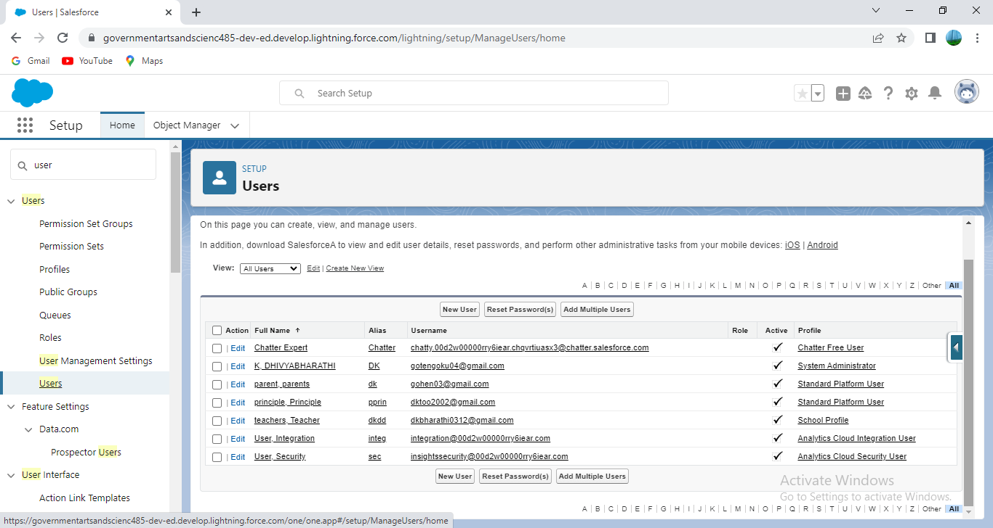

**Milestone-7:Permission sets**

A permission set is a collection of settings and permissions that give users access to various tools and functions. Permission sets extend users' functional access without changing their profiles.

Activity-1:

Permission sets 1:

1. From Setup, entered Permission Sets in the Quick Find box, then selected Permission Sets. 2. Clicked New.

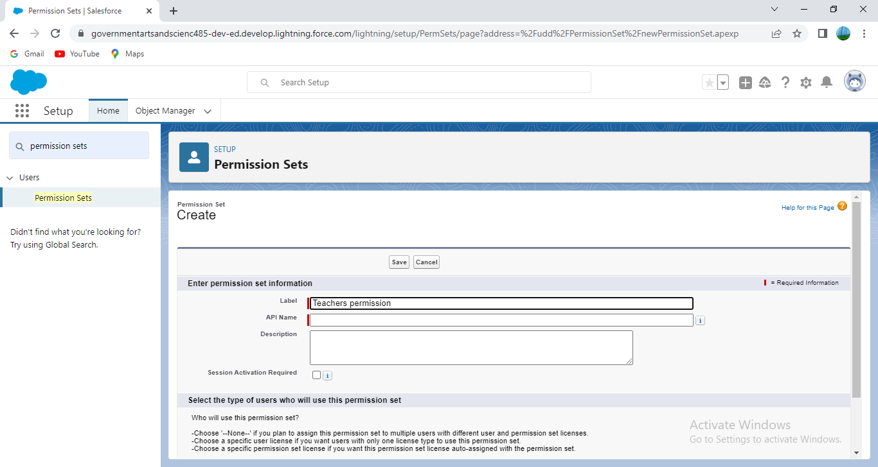

3. Gave the name of the Permission set name as teacher permission and then under the object settings gave the view create and edit permissions to all custom objects and assigned to the teacher user.

Similarly followed the above steps for the permission set 2.

**Activity 2:**

Permission sets 2: 1. From Setup, entered Permission Sets in the Quick Find box, then selected Permission Sets. 2. Clicked New.

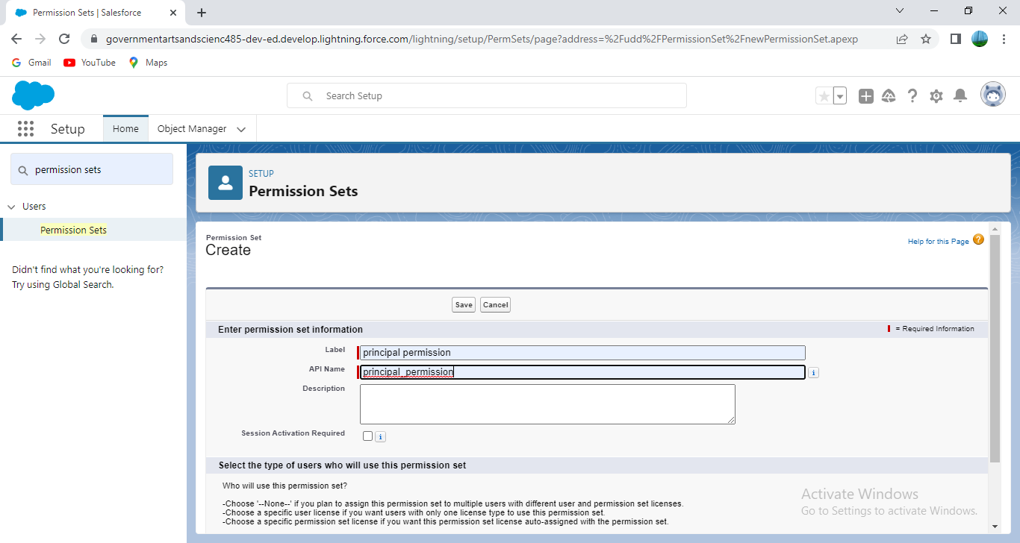

3.Gave the name of the Permission set name as Principal permission and then under the object settings gave all permissions for the custom objects and assigned them to the Principal user.

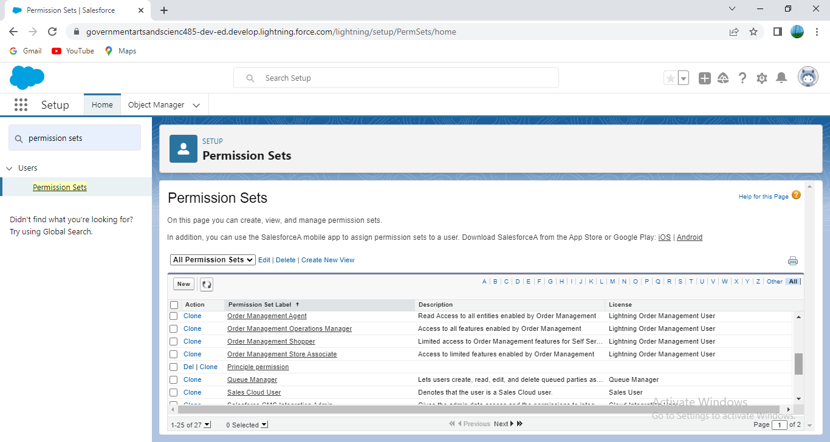

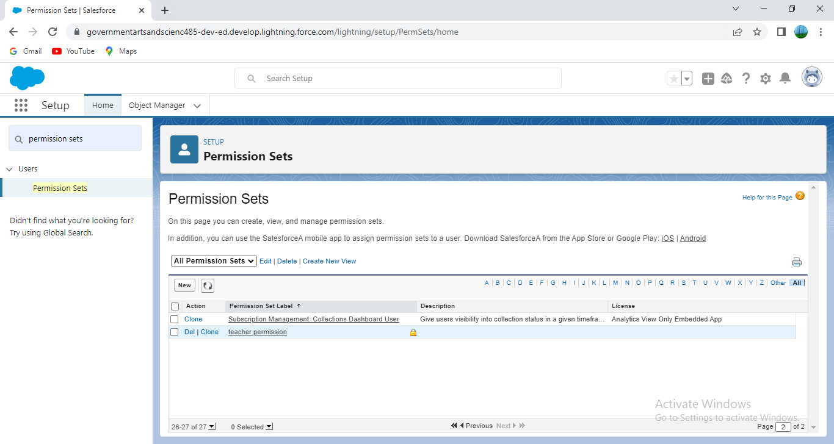

**Milestone-8 : Reports**

A report is a list of records that meet the criteria define. It's displayed in Salesforce in rows and columns, and can be filtered, grouped, or displayed in a graphical chart. Every report is stored in a folder. Folders can be public, hidden, or shared, and can be set to read-only or read/write.

Activity:

Reports : 1. From the Reports tab, clicked New Report. 2. Selected the report type as School with students and parents for the report, and clicked Create.

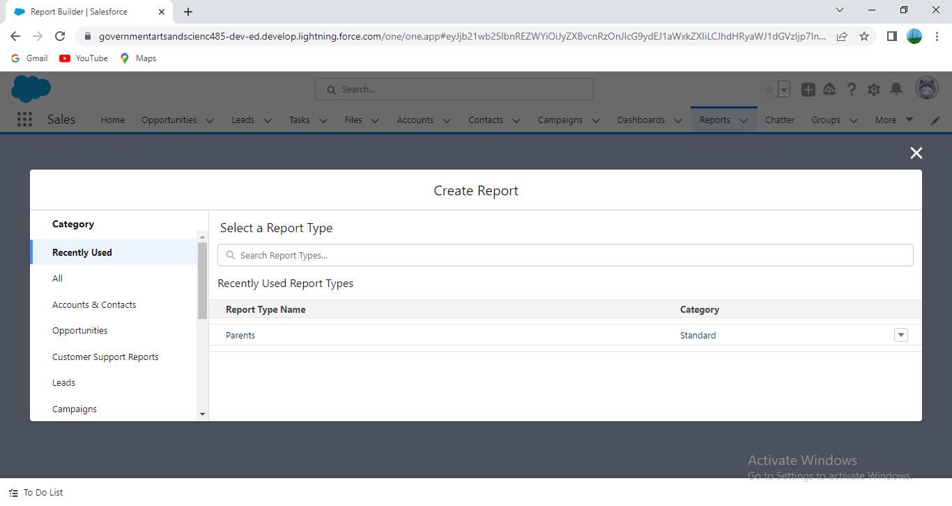

1. Customized our report, then clicked save or run it.

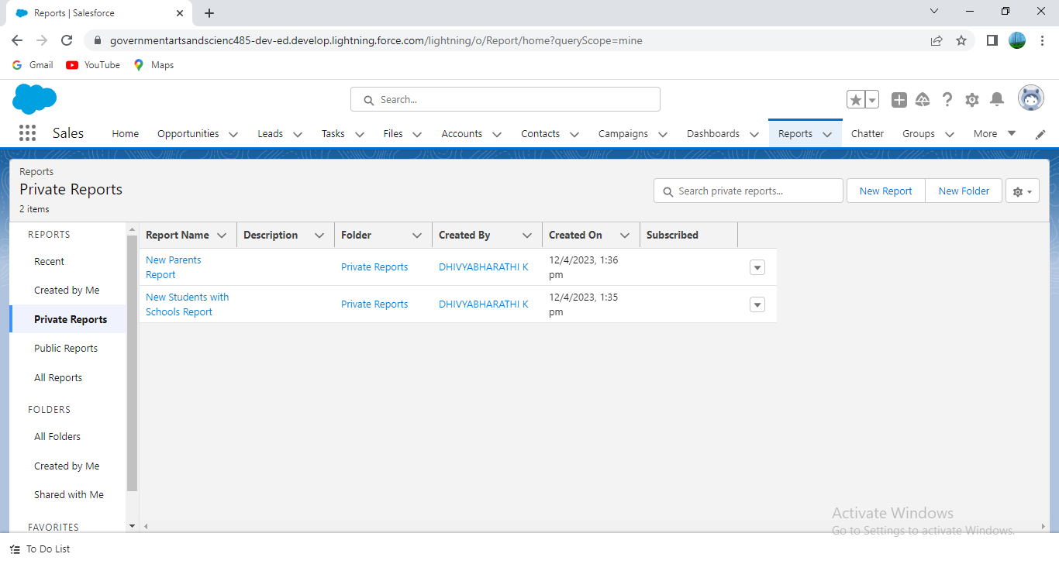

Completed the Milestones.

**Trailhead Profile public URL**

**Team Lead** **-** **MEGHA .T -** [trailblazer.me/id/meg28](https://trailblazer.me/id/meg28)

**Team Member 1 - AFRIN BEGUM .S -** [trailblazer.me/id/afris23](https://trailblazer.me/id/afris23)

**Team Member 2 – DHIVYABHARATHI .K -** [trailblazer.me/id/dk0312](https://trailblazer.me/id/dk0312)

**Team Member 3 –RUTHRA MADHAM .M -** [trailblazer.me/id/ruthm40](https://trailblazer.me/id/ruthm40)

**ADVANTAGES & DISADVANTAGES**

**Advantages :**

**Improved Informational Organization**

**The more you know about your customers, the better you’ll be able to provide them with the kind of positive experience that really pays off. Everything that they do, and every interaction that they have with your organization needs to be identified, documented, and recorded. To do this, you need to move beyond the sticky-notes and disorganized filing cabinets, and start utilizing advanced organizational technology that can not only accurately quantify and categorize data for easy future reference, but also make that data available across departments. Thanks to CRM this all becomes a possibility, it allows you to store a vast list of customers and any important information regarding them. Access to their file is even more convenient than before due to the cloud, so no matter who it is that is helping the customer in question, they’ll have the same actionable data instantly available. This will result in less wasted time for clients and employees.**

**CRM for Enhanced Communication**

**As mentioned above, CRM makes it possible for any employee to provide the same high level of service, by having access to the same customer data. After all, even if your customers have a single, main point of contact, there’s a good chance that at some point that contact may not be available, and the client will be forced to have to work with someone new. When that happens, many customers face the unhappy prospect of having to ‘start fresh’ with someone who doesn’t understand their own unique preferences and issues. CRM does away with this concern, by making detailed customer information communicable to whomever might need it. As such, it won’t matter who it is that is currently assisting the client, because they’ll be working from the same information. And given that CRM is cloud-based and accessible from any device with an internet connection, the communication benefits of mobile CRM are not limited to the office.**

**Disadvantages :**

**1. Removes the Human Component from the Business Equation**

**Many companies use CRM systems with the main objective of improve the customer experience. It minimizes the human to human interaction and replaces it with machines.**

**However, the capabilities of a machine or software are limited. However, BPO companies use CRM software in conjunction with Contact Center software and other tools to automate processes where possible to open up humans for important interactions with customers.**

**Therefore, it cannot give customers the solutions only a human can give. Customers can feel more comfortable and feel better speaking to a person rather than an answering machine on the other end. Therefore, using CRM can reduce the element of human interaction in your business operations.**

**2.Proper Employee Training and Adoption**

**While there are many examples of CRM and how it can give your business a plethora of benefits, it will take some time before you can enjoy them. Your employees are a vital stakeholder of your business before your customers. So, they must grasp the system to serve your customers in a better way.**

**And all of this means extensive training programs where you have to teach everything to your employees about CRM.**

**In addition, you will have to carry about industry-specific training programs for the training for employees. All in all, it can be a hectic and time-consuming task that can drain your employees' energy as well as yours.**

**APPLICATIONS:**

**CRM applications are software that help businesses manage their customer interactions and relationships. They can be installed on a computer or a website and can support various business tasks such as scheduling, invoicing, order processing, and account management. They can also integrate with communication systems and provide data analysis and reporting5. CRM applications aim to improve customer satisfaction and profitability.**

**CONCLUSION :**

**Customer Relationship management is a business strategy that enables a business organization tomaximize revenue, customer satisfaction, profitability through strategic mobilization, organization, and management of customer’s interests and desires. The system has significantly contributed to the company’s financial, operational, managerial and development initiatives with a robust customer relationship that has fostered great sale of its product.**

**FUTURE SCOPE :**

**The future of CRM is bright. CRM will continue to report key data and give insight for future action, however, leading experts see CRM evolving to measure and inform sales enablement and customer engagement while playing a tremendous role in the success of future business. The evolution of CRM will help us answer Pombriant’s questions in a 360-degree view. With all the data available today, organisations have an unprecedented opportunity see customers in more detail than ever. The mindset of keeping the customer in the fold will be more important as the cost of changing from one provider to another becomes very low. Traditional forced loyalty programs such as frequent flier may not be enough to keep the customer in the fold, says Pombriant.**